# Big-Oh notation



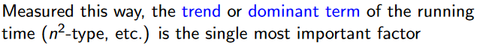



# Searching Algorithms

## A screenshot of a computer code Description automatically generatedLinear Search

## Binary search



# Sorting Algorithms

## Selection Sort

## A white background with black text Description automatically generatedInsertion Sort



## A white background with black text Description automatically generatedMergesort

Merging

Sorting Tree

## Quicksort

Divide step

Partition step

# Data Structures

## ArrayList

## A diagram of a number and a circle Description automatically generated with medium confidenceLinked Lists

## A screenshot of a computer code Description automatically generatedTrees

Binary Search Trees





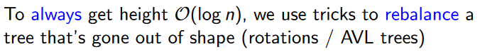



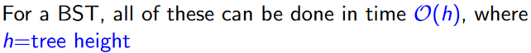

#### Deletion of a node





#### A white text with black text Description automatically generatedSelf-balancing BSTs

##### AVL Trees

After insertion / deletion of a node

Backtrack, checking the heights of nodes

If node.height is 2

If node.left.height >= 1

Right rotate node

Else left rotate node.left and then right rotate node

Else if node.height is -2

If node.right.height <= 0

Left rotate node

Else right rotate node.right and then left rotate node

________________________________________________

When rotating right around a node, drop left node pointer and hook it onto left subtrees right node, with the left node now being the parent.

When rotating left around a node, drop right pointer and hook it onto right subtrees left node, with the right node now being the parent.

## ADTs

Stack

Queue

#### Double-ended queue

#### A white background with black text Description automatically generatedA white text with black text Description automatically generatedPriority Queue

##### A close up of words Description automatically generatedA white background with black text Description automatically generatedBinary Heaps

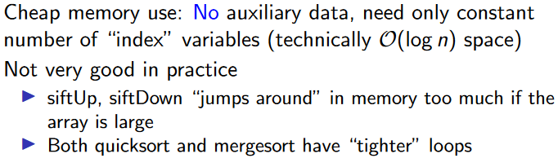

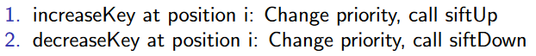

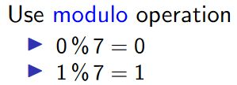

Hash tables



Set

Map

# Hash functions

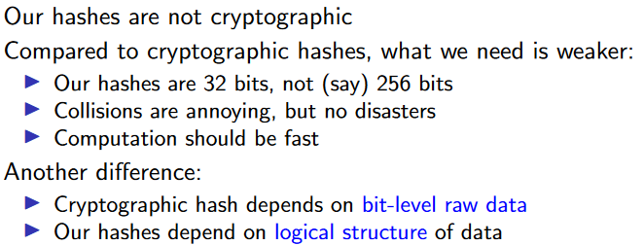





# Dynamic programming

# A white text with black text Description automatically generatedString Matching



# A screenshot of a computer Description automatically generatedComplexity Tables

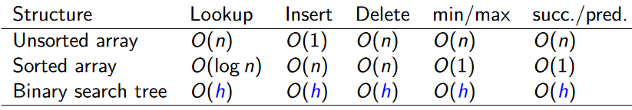

# A hexagon with lines and circles Description automatically generatedA diagram of a graph Description automatically generatedGraphs

## Graph traversal

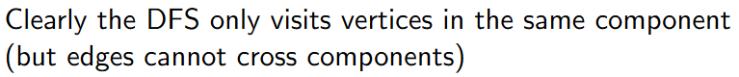

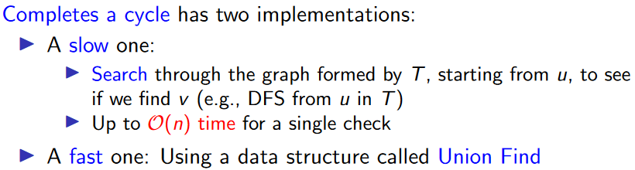

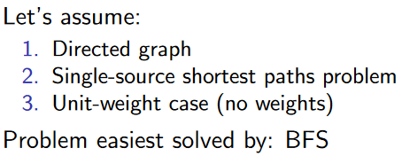

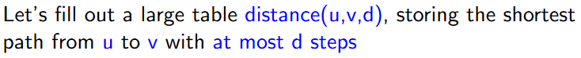

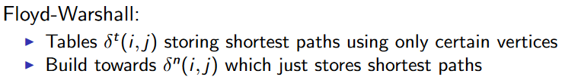



## A white background with black text Description automatically generatedGreedy Algorithms

